**Administrator: Eingabeaufforderung**

C:\WINDOWS\system32>net localgroup docker-users Family /ADD

Der Befehl wurde erfolgreich ausgeführt.

C:\WINDOWS\system32>cd C:\Users\Family\git\kafka-spring-boot-example

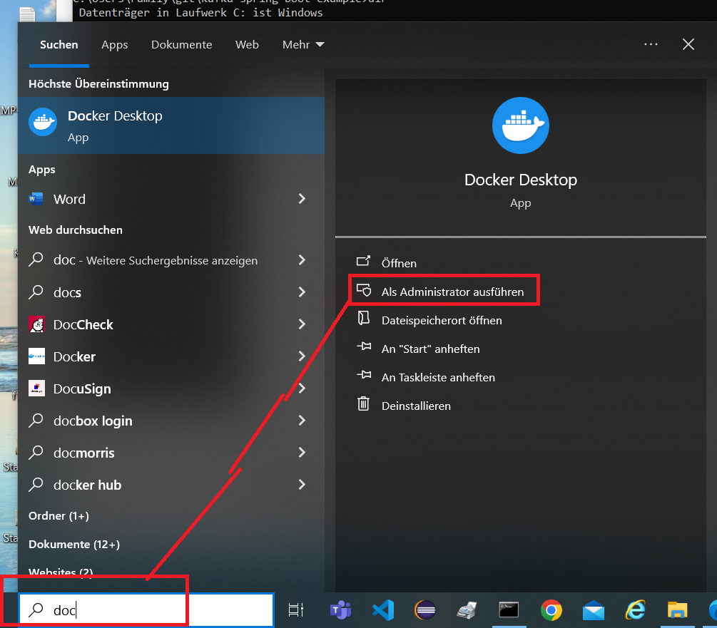



**Logout and Restart**





**Click 🡪 Sign up**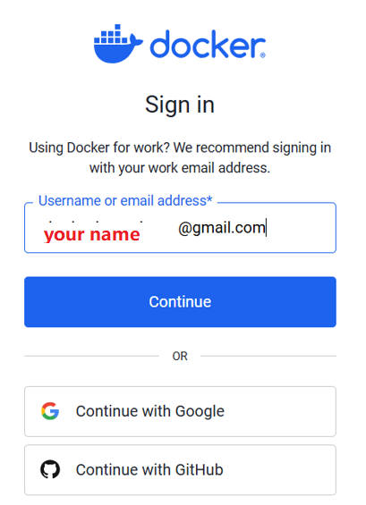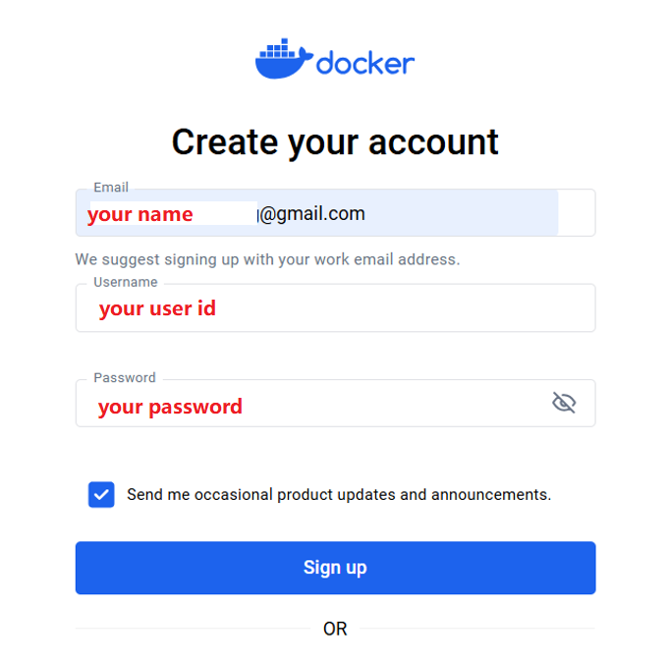

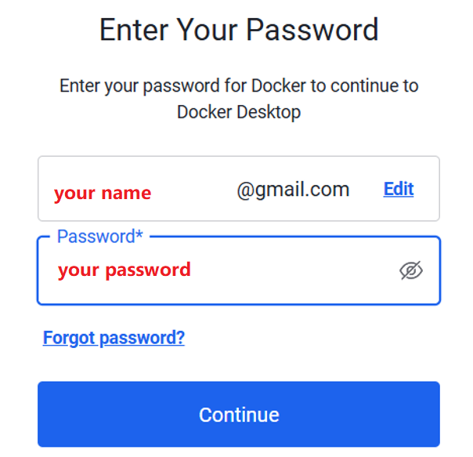





Login with eMail

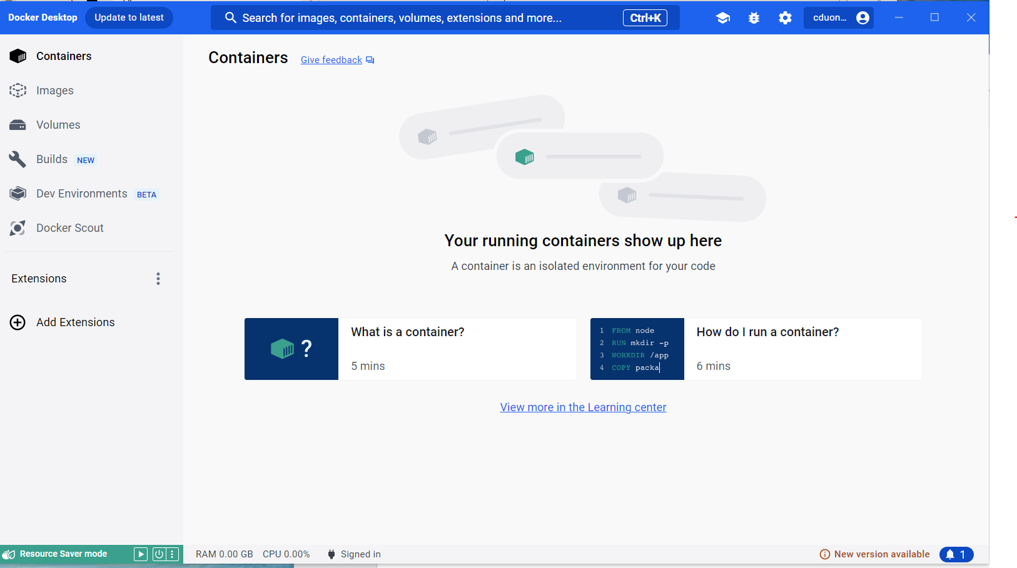

docker-compse.yml 🡪 Exist

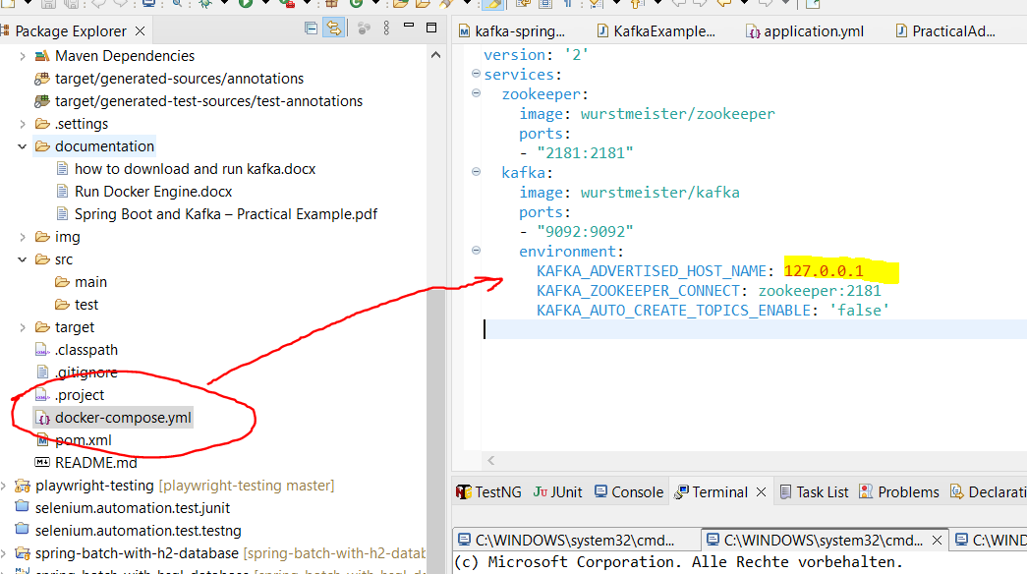

On C:\Users\Family\git\kafka-spring-boot-example>docker-compose up

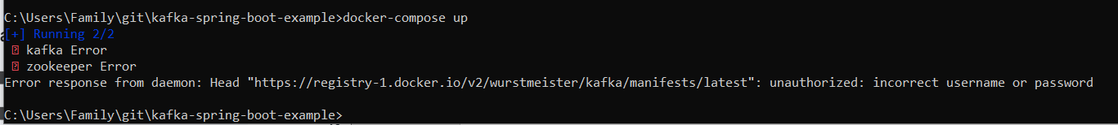

✘ kafka Error 1.1s

✘ zookeeper Error 1.1s

Error response from daemon: Head "https://registry-1.docker.io/v2/wurstmeister/kafka/manifests/latest": unauthorized: incorrect username or password

Login with Email and got the unauthorized: incorrect username or password

**Logout** 🡪 and then **login** with userid your userid

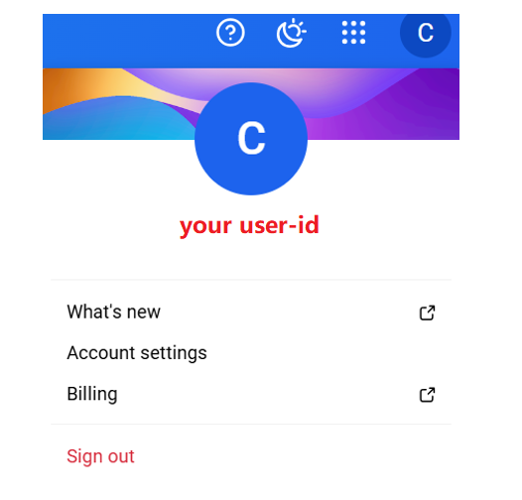

Click 🡪 Sign Out

<https://app.docker.com/logout>



Login

<https://app.docker.com/login>



Login with Userid: your userid 🡪 OK



Type: docker-compse up

Docker Engine run 🡪 OK

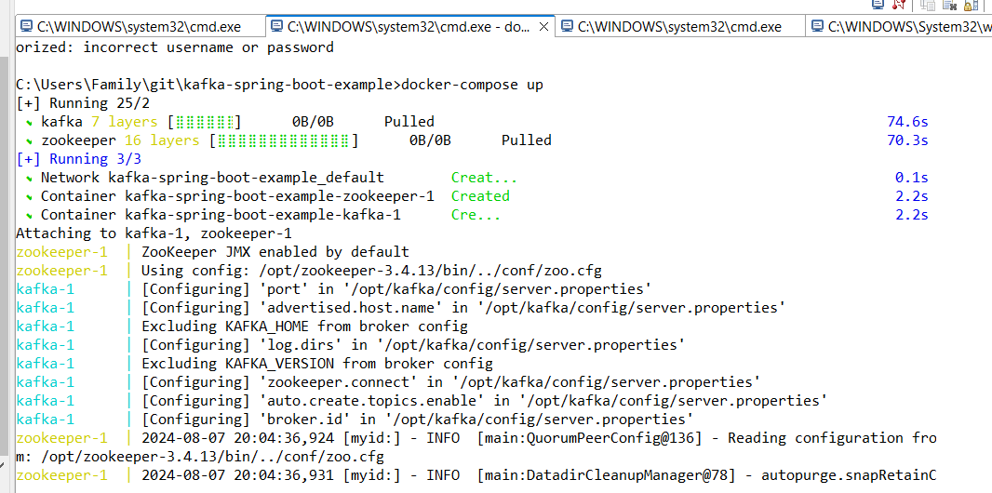

Run: KafkaExampleApplication 🡪 Result: OK

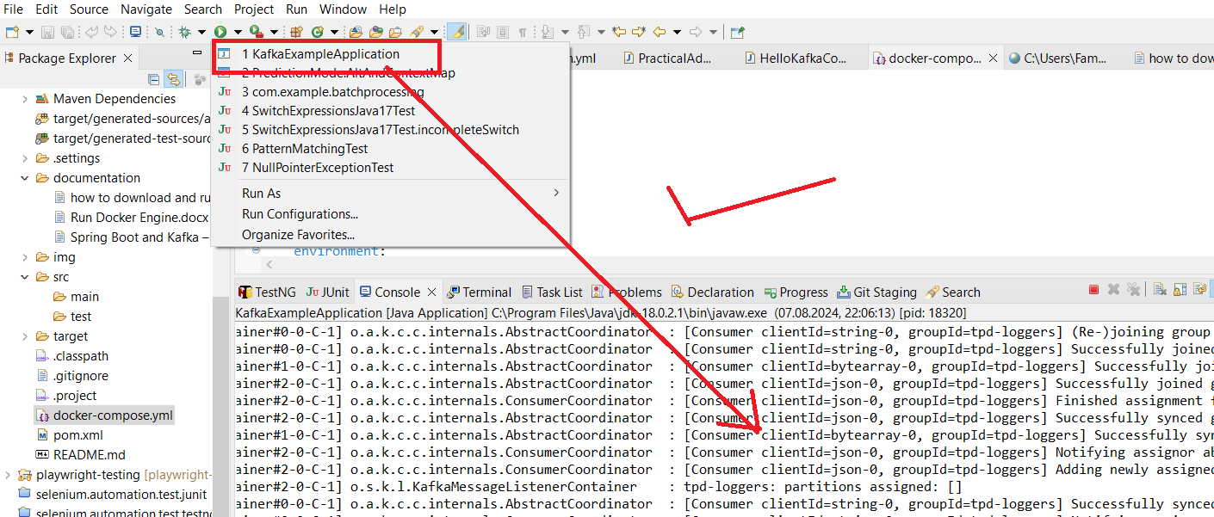

Go to document 🡪 “how to run docker engine and docker-compose up on window 10.docx” 🡪 to run the docker engine